Flash Gordon Development Guide
© Blanchard Lab, 2014-2017
Version 0.6.1
Written by Manuel Juette

Prerequisites
Prerequisites for running Flash Gordon are listed in release.txt. For development, the following additional requirements need to be met:
- Visual Studio 2015 with C/C++ tool chain (free Community Edition is sufficient). This is recommended to compile the C DLLs used for time-critical operations in Flash Gordon.

Introduction
Flash Gordon is an instrument control software package for widefield single-molecule fluorescence measurements, especially smFRET, with up to four sCMOS cameras (currently supported: Hamamatsu Orca-Flash 4.0 V2).
The architecture is based on the LabVIEW Actor Framework and aims to provide enough abstraction and modularity to allow for relatively easy adaptation to different setups. This is, however, a work in progress; currently, only setups very similar to the microscopes in the Blanchard lab (as described in http://dx.doi.org/10.1038/nmeth.3769) are expected to work without major modifications.
This guide explains specific design features and development workflows for Flash Gordon. It is not a general introduction to the Actor Framework or LabVIEW. A good starting point to learn the basics of the actor framework is the Actor Framework Fundamentals project from the Example Finder, along with documents found at https://goo.gl/A86KuP.

Structure

Subsystems
Flash Gordon is divided into the following three subsystems:
- Application. This is the core system that handles initialization and shutdown, other general tasks, and communication between the other subsystems. The Application actor owns most dependent actors and is the recipient/redistributor of most messages.
- User Interface (UI). This encompasses the Main Window and Viewer actors as well as actors for dialog boxes, progress windows etc. Together, these actors handle all user interactions.
- Hardware. Handles the communication with the microscope hardware. This is subdivided into two layers:
  - Hardware abstraction layer (HAL). Provides generic device actors (camera, microscope stand, etc.) which can receive messages from the Application actor and reroute them to the appropriate device layer actors corresponding to the initialized hardware.
  - Device layer. Provides actors for all supported hardware devices that interface with the specific device drivers and handle instructions from the HAL.
Note that the implementation of the HAL is still very incomplete. Currently, the Application actor still communicates directly with most of the device layer actors, with the exception of the Virtual Camera actor, which provides a hardware-independent wrapper for the device actors directly interacting with the camera driver.

Class Hierarchy
The main classes within Flash Gordon are actors, which are derived from the Actor Frameworks Actor class. The core Application actor implements the Application subsystem. UI Window and Device are abstract classes that provide generic functionality for the UI and Hardware subsystems; specific windows and devices are implemented by subclassing. Messages between actors are derived from a separate Message class, which is also part of the framework. For saving BigTIFF files, Flash Gordon uses the BinaryTIFF class, which is provided as a separate LabVIEW project.
A schematic of the class hierarchy is shown in Fig. 1. This can also be displayed using View > LabVIEW Class Hierarchy in the Project Explorer.

Configuration files
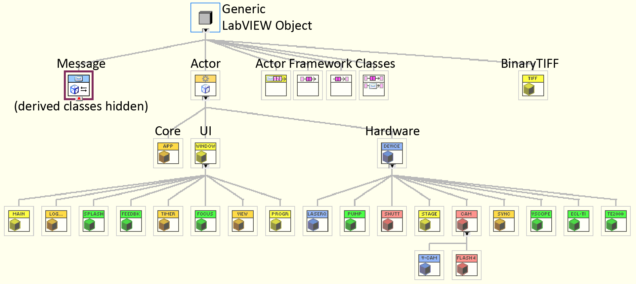
Flash Gordon uses two types of configuration files. Both are XML files based on LabVIEW’s own schema and type-def’d clusters. This makes them easy to generate using VIs, while also being reasonably human-readable and editable. Init.xml in the main project directory contains general settings, while the Config directory can contain any number of hardware configuration files that define camera channels, COM ports and other specifics of the available devices.
Figure 1. Flash Gordon class hierarchy.

Walkthrough
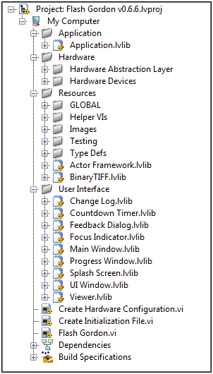
Always open the project file (.lvproj) in the Flash Gordon directory to examine the code or make any changes. Fig. 2 shows the general structure of the project.
At the top level, there are only three VIs:
- Flash Gordon.vi – This is a minimal launcher for the top-level Application actor, which handles all other tasks. This VI is configured to auto-launch when loaded directly from the Windows Explorer.
- Create Initialization File.vi and Create Hardware Configuration.vi – As the name implies, these VIs provide a simple way to write the required config files. They do not provide Front Panels, so you’ll need to edit the Block Diagram to change settings.
All other components are contained in virtual folders. Application, Hardware, and User Interface contain the subsystem actors described above. Resources contains type defs, global variables, and various VIs used for development/testing.

Subsystem folders
Within the virtual folders for the different subsystems, each actor is contained in a separate LabVIEW library (.lvlib) file. This includes:
Figure 2. Structure of the project file.
- A virtual folder with the message classes for this actor.
- The actor class itself. This, in turn, contains the private data cluster and separate virtual folders for protected and public methods, getters and setters. Notes:
  - LabVIEW does not enforce any particular organization of class members. Adhering to a fixed virtual folder structure prevents confusion.
  - Each public method corresponds to a message class and vice versa, as this is the framework’s mechanism to expose functionality to calling actors.
Fig. 3 shows an example of the actor library structure. As a reminder, each actor contains at least a protected Actor Core.vi, which handles the core functionality of the actor, either in a linear fashion (e.g. the application actor, which handles initialization tasks sequentially – Fig. 4), or in a while loop that handles repeated activities and program state changes (Fig. 5).
Additionally, many actors contain Pre Launch Init and Shut Down VIs to handle tasks required during launch and termination of the actor (see note 7.1 for limitations of Pre Launch Init).

Program flow
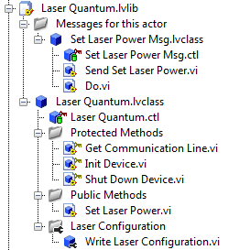
Flash Gordon.vi launches the Application Actor. Since this actor has no Pre Launch Init, it goes straight to its Actor Core.vi (Fig. 3), which first handles all initialization tasks: load config files, display the splash screen, and load Init Hardware.vi (Fig. 4). This VI launches all the required hardware actors based on the configuration file. Once the hardware is ready, the Main Window actor is launched, which subsequently handles most user input. The Application actor remains active and waits for any messages from its child actors. The program is terminated when the Main Window sends a stop signal to the Application actor. No specific shutdown code is required within the Application actor, as all nested actors are set to “auto-stop” together with their calling actor (at which point they all execute their respective termination code).
Figure 3. Structure of an actor library.
Figure 4. Example of a simple linear VI (Init Hardware.vi).
The Main Window actor core contains the central event handling loop of the application (Fig. 5). For live preview or movie recording, a secondary UI window, the Viewer is launched, which handles all operations related to displaying the current frame to the user.

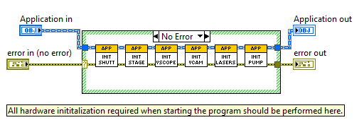
Making changes

Creating a message

Editing a message

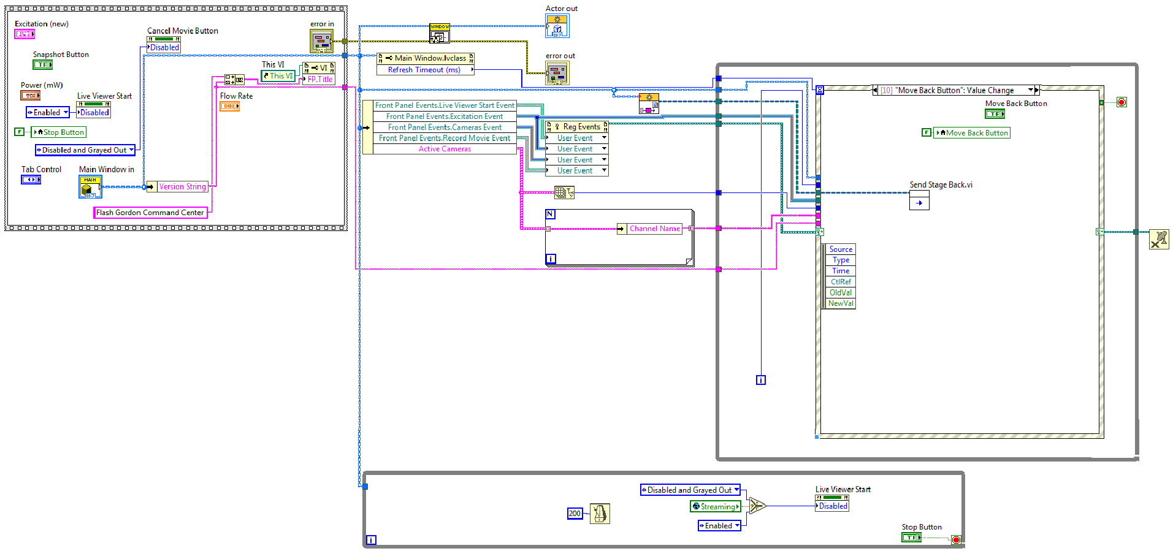
Creating a new version
Figure 5. Example of an Actor Core.vi (in this case for the Main Window) with some initialization code (top left) and parallel event and state handling loops (top right, bottom).

Additional components

BinaryTIFF
This is a standalone LabVIEW/C project used to combine Hamamatsu HD recorder files (DCIMG) into BigTIFF stacks, where the different spectral channels are tiled side-by-side (up to four channels in a 2×2 grid). The generated files contain OME-Tiff metadata. For further documentation, see project directory.

Framehist
This C-based DLL is used to calculate the histogram of the current frame (along with upper and lower LUT thresholds for auto-ranging).

Prepdisp
This DLL is currently under development and will be used to prepare the current frame to be displayed in the Viewer. This should speed up the refresh rate and responsiveness of the viewer windows, especially when more than two cameras are active.

Various notes and guidelines

Actor initialization
Note about using the Pre Launch Init method: actors CANNOT be launched there (attempting this will cause the program to hang without any error message). Thus, the best place for most initialization code is the actor core itself. Pre Launch Init should only be used to check if pre-requisites for running the core are met (e.g. parameters initialized?) and abort launching the actor if necessary.

Actors with displayed front panels (i.e. UI windows)
Don’t wire TRUE to “Show Front Panel” option when launching the actor, as this will not work for built application. Use VI properties of Actor Core instead.

Communication between actors
The primary communication mechanism between actors are messages. This works well for most cases, but has two disadvantages for certain time-critical operations: (i) they create overhead; (ii) they act asynchronously. For this reason, certain time-critical data (e.g. live frame) or status flags that must be propagated synchronously (e.g. status of the recording stream) is currently shared via a global variable named GLOBAL Time-critical.vi, which is found in the Resources virtual folder. This leads to intransparent code and some undesired side effects and should be handled with more appropriate synchronization mechanisms (queues/notifiers) in the future.
As discussed in section 3.1, implementation of the HAL is a work in progress and will eventually allow better modularity for handling communication with different devices and provide abstract classes as templates for easy implementation of specific device driver interfaces. It is also planned for the near future to include hardware status indicators (stage position, laser power etc.) in the GUI. A decision needs to be made on the best mechanism to share this information with the Main Window.

Team development
Due to LabVIEW’s graphical nature and binary source code, source code control and team development differ from text-based languages. Currently, no source code control is in place for Flash Gordon. Contributions by multiple programmers need to be handled on a case-by-case basis and integrated manually into the main code base.

